Lab Objective

Learn how to Use an Active Directory Snapshot

**Lab Procedures**

**1.** Log in to Server01 as the **Contoso\Administrator** user account. The Server Manager console opens.

**2.** Right-click the Start button and select Command Prompt (Admin). The command prompt window opens.

**3.** At the command prompt, execute the ntdsutil command.

**4.** At the ntdsutil prompt, execute the snapshot command.

**5.** At the snapshot prompt, execute the activate instance ntds command.

**6.** Execute the create command.

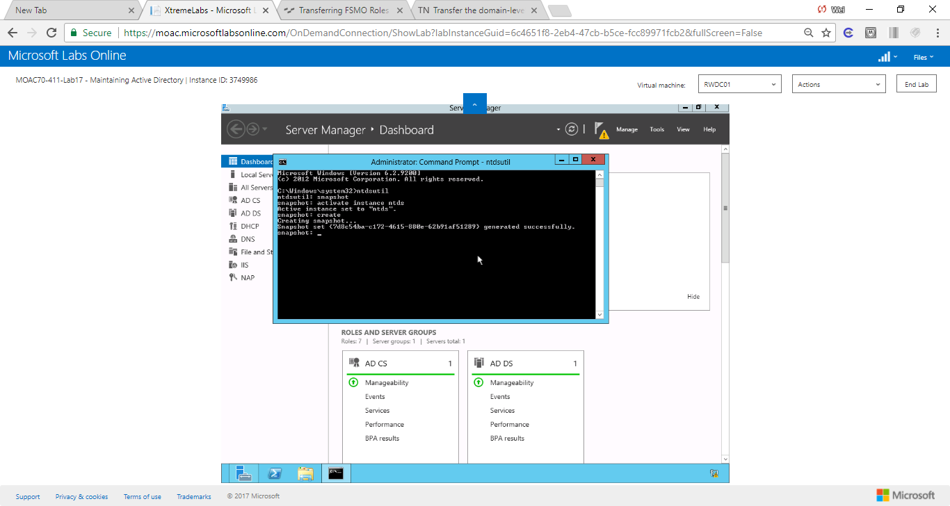

Figure Create a snapshot in command window

|  |  |
| --- | --- |
| Question 2 | What is the Guid (without the braces ({})) of the snapshot created? |

**7.** To return a list of all snapshots, at the snapshot prompt, execute the list all command.

**8.** Execute the mount {GUID} command, where GUID is the one that you recorded.

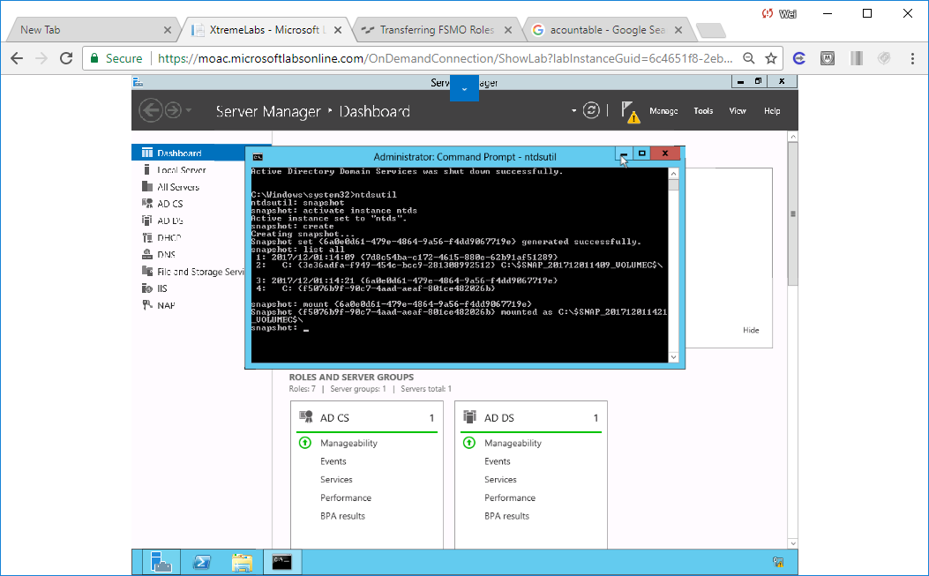

Figure Created a snapshot and mounted {GUID = 6a0e0d61-679e-4864-9a56-f4dd9067719e}

**9.** Take a screen shot of the ntdsutil Command Prompt window by pressing Alt+Prt Scr and then paste it into your Lab17_worksheet file in the page provided by pressing Ctrl+V.

**10.** Execute the quit command twice to exit ntdsutil.

**11.** To mount the snapshot, execute the following command:

dsamain -dbpath c:\$snap_datetime_volumec$\windows\ntds\ntds.dit

-ldapport 5000

You need to specify the date-time when you performed the mount command. The port number, 5000, can be any open and unique TCP port number (see Figure 17-2).

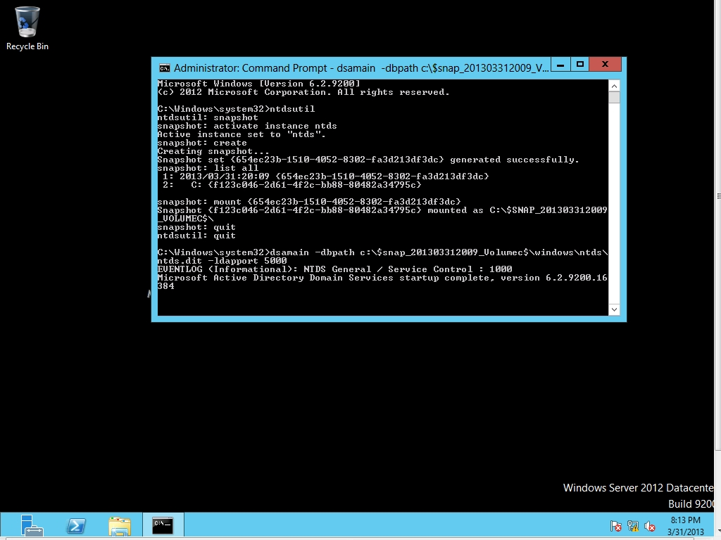

Figure 17-2

Mounting a snapshot

**12.** A message indicates that Active Directory Domain Services startup is complete. Do not close the command prompt window and leave the command you just ran, dsamain.exe, running while you continue to the next step.



Figure A message indicates that AD DS is complete

**13.** Using Server Manager, click Tools > Active Directory Users and Computers. The Active Directory Users and Computers console opens.

**14.** Right-click the contoso.com, and then click Change Domain Controller. The Change Directory Server dialog box appears.

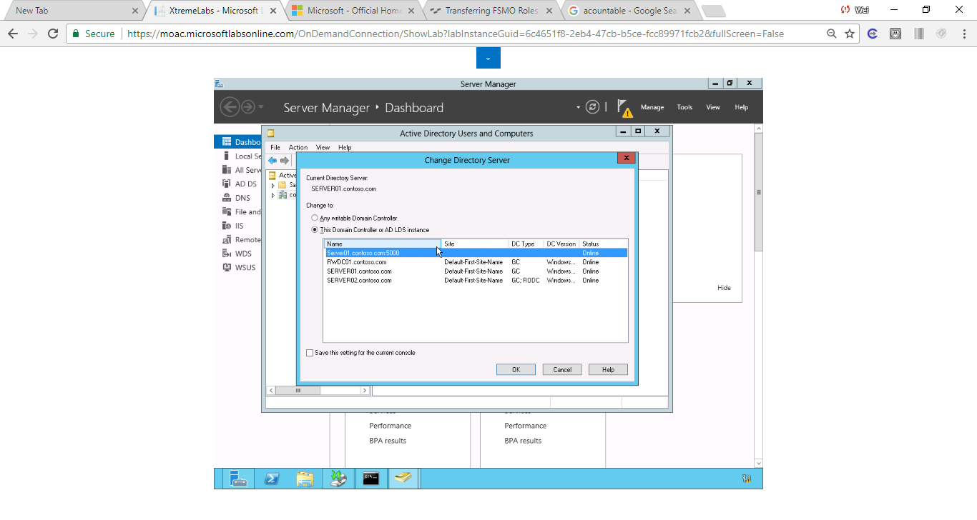

Figure screenshot shows Change Directory Server dialog box. Server01.contoso.com:5000 is online.

**15.** Click <Type a Directory Server name[:port] here>, type **Server01.contoso.com:5000**, and press Enter.

**16.** Click OK. You are now viewing the users and computers that are stored in the snapshot.

**17.** Switch to the command prompt in which the snapshot is mounted.

**18.** Press Ctrl+C to stop DSAMain.exe.

**19.** Execute the ntdsutil command.

**20.** Execute the activate instance ntds command.

**21.** Execute the snapshot command.

**22.** Type **unmount <GUID>**, where GUID is the GUID of the snapshot, and then press Enter.

**23.** Execute the list all command.

**24.** Because the snapshot is the first entry in the list, execute the following command:

delete 1

**25.** Execute the quit command twice.

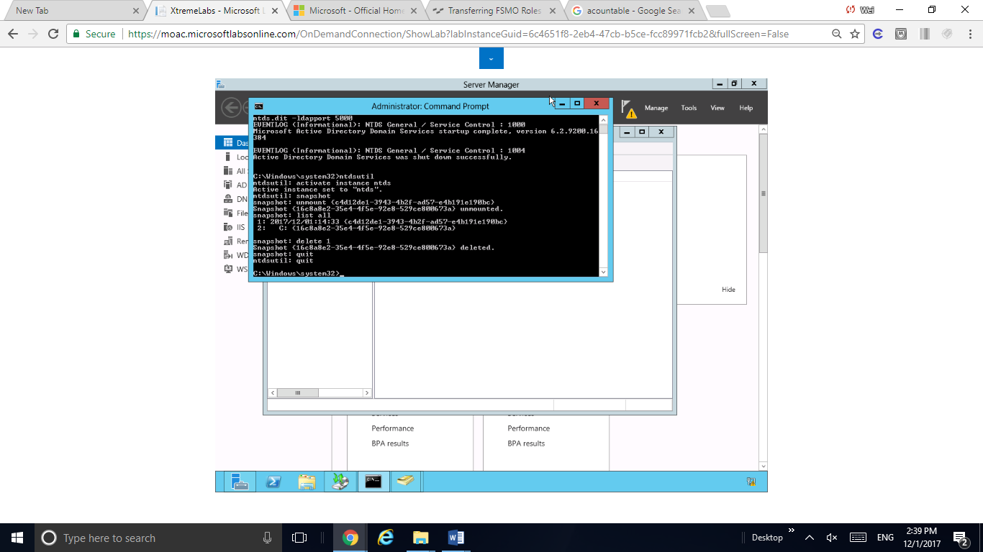

Figure {16c8a8e2-35c4-4f5c-92c8-529ce800673a} unmounted and deleted.

**26.** Take a screen shot of the ntdsutil Command Prompt window by pressing Alt+Prt Scr and then paste it into your Lab17_worksheet file in the page provided by pressing Ctrl+V.

**27.** Close the command prompt window and the Active Directory Users and Computers console.

End of exercise.

**Lab Summary**

During this exercise, I created a snapshot of Active Directory using cmd, and mounted and accessed the snapshot. At the end,the snapshot was unmounted and deleted. Active Directory has the ability to create snapshots. Active Directory snapshots allow me to view Active Directory usingtools such as Active Directory Users and Computers so that you can compare to my current Active Directory. The biggest limitation is that I cannot copy objects from the snapshot.